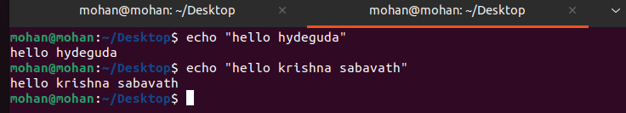1.Echo command

2. Single Redirections > command

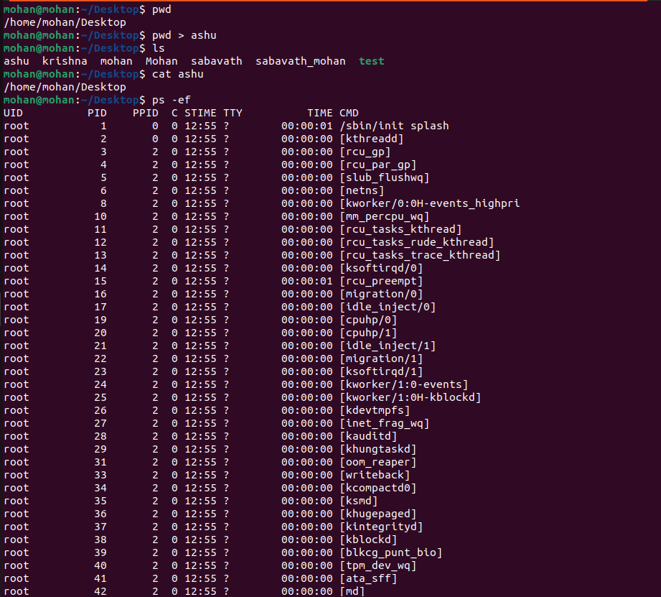

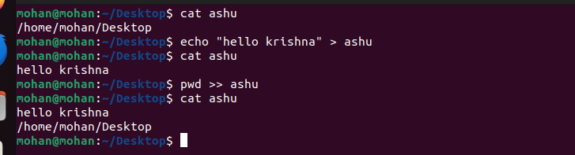3. Double Redirection >> command

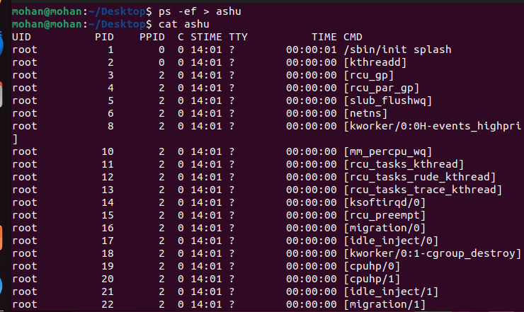 4.Storing files in Desktop with the help of (ps -ef) command

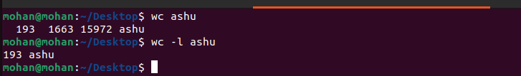 5.word Count existing in the file

6.wc-l line count of existing files

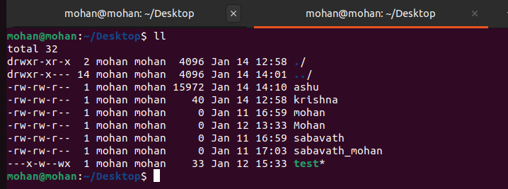

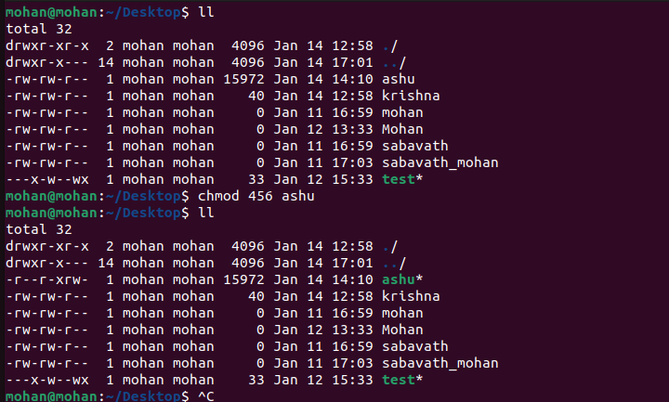7.Change the permission of command Chmod

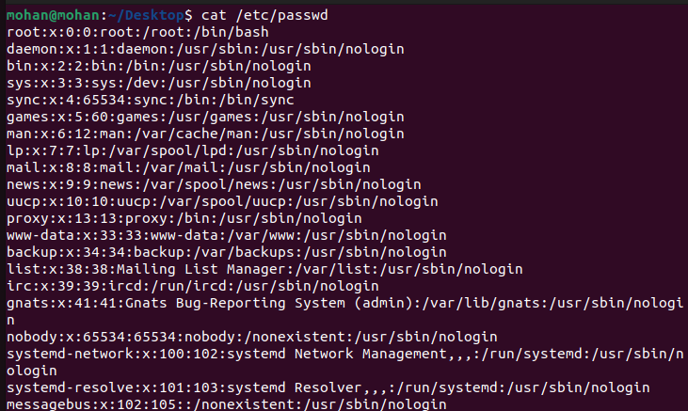8.To check the No of user in the system {Cat /etc/passwd} command

9.switching between users : su user name

